**Execute PowerShell commands for Microsoft Teams**

* **Step 1**: Download and install the Skype for Business Online Connector module (one-time activity)
  + <https://www.microsoft.com/download/details.aspx?id=39366> - Download the SkypeOnlinePowershell.exe file
  + Double-click the SkypeOnlinePowershell.exe file and install in your machine
  + In the Skype for Business Online, Windows PowerShell setup wizard, on the Microsoft Software License Terms page, select I accept the terms in the License Agreement, and then click Install. If the User Account Control dialog box appears, click Yes to continue the installation.
  + On the Completed the Skype for Business Online, Windows PowerShell Module page, click Finish.
* **Step2**: Connect Office 365 from a Single instance of Windows PowerShell

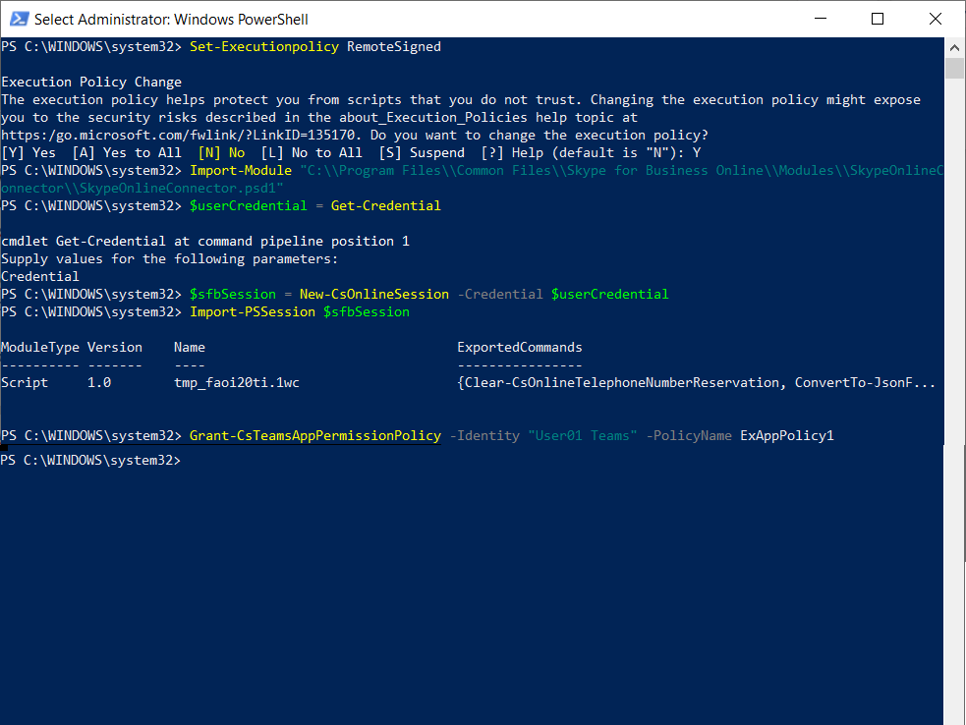

* + Open windows Power shell as an administrator
    - Run as administrator
  + *Set-Executionpolicy RemoteSigned*
    - Enter Y
  + Import SkypeOnlineConnector to this instance
    - *Import-Module "C:\\Program Files\\Common Files\\Skype for Business Online\\Modules\\SkypeOnlineConnector\\SkypeOnlineConnector.psd1"*
  + Run below command to validate or get credentials
    - *$userCredential = Get-Credential*
  + Get Skype for Business session
    - *$sfbSession = New-CsOnlineSession -Credential $userCredential*
  + Import the sfb session
    - *Import-PSSession $sfbSession*

Then execute the policy command